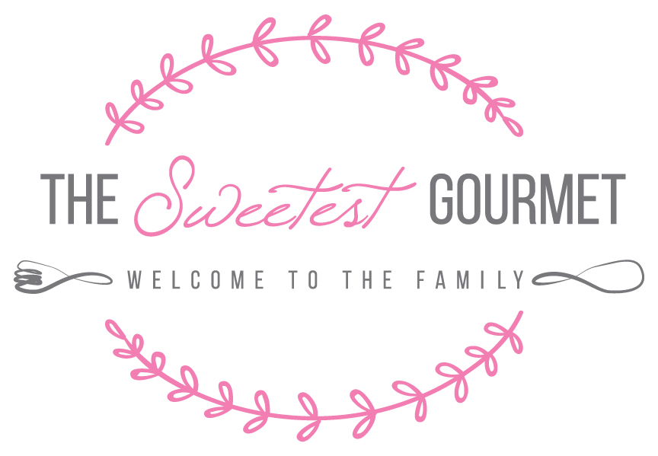

Contact us at 248-613-7944

MENU

Packages
Breakfast Package Options
Lunch Package Options
Dinner Package Options
Dessert Package Options

Additional Services

A la Carte
Breakfast
Sandwiches
Appetizers
Salads
Entrees
Desserts

Breakfast Options

- Continental Breakfast- $6/person
  - Fresh cut fruit bowl
  - Assorted homemade breakfast pastries (2 pieces per person)

- Continental Breakfast with Beverage Service- $8.50/person
  - Fresh cut fruit bowl
  - Assorted homemade breakfast pastries
  - Assorted juices (orange, cranberry, apple)
  - Coffee (1 cup/person) and tea service including creamers and sugars
    - Additional coffee service available upon request @ $1.50/cup

- Hot Breakfast- $12.50/person
  - Fresh cut fruit bowl
  - Choice of: crustless quiche, classic or pecan french toast
  - Choice of: bacon (2 slices/person), sausage links or sausage balls
  - Assorted homemade breakfast pastries (1/person)
- Hot Breakfast with Beverage Service- $15/person
  - Fresh cut fruit bowl
  - Choice of: crustless quiche, classic or pecan french toast
  - Choice of: bacon (2 slices/person), sausage links or sausage balls
  - Assorted homemade breakfast pastries
  - Assorted juices (orange, cranberry, apple)
  - Coffee (1 cup/person) and tea service including creamers and sugars
    - Additional coffee service available upon request @ $1.50/cup

A la Carte

- Seasonal Fruit Bowl- $3/serving
- Breakfast Breads- $12/loaf
  - Banana, pumpkin, lemon poppyseed, zucchini
- Muffins- $2/per
  - Blueberry, apple-cinnamon, banana, mixed berry, carrot
- Scones- $2/per
  - Chocolate chip, cranberry-orange, dried cherry
- Crustless Quiche- $3/serving (min 12 servings)
  - Cheese, ham/sausage, vegetarian

- Breakfast Strata- $3/serving (min 12 servings)
  - Cheese, ham/sausage, vegetarian
  - Served with potatoes or seasoned bread
  - French toast casserole - $2/serving (min 12 servings)
  - Praline Pecan French Toast Casserole- additional $2/serving

Lunch Options

- Assorted sandwiches, chips, cookies- $8.50 person
  - Sandwiches (1 full size or 2 petite):
    - Turkey/cheddar, ham/swiss, roast beef/gouda, Italian sub, chicken/egg/tuna salad, grilled chicken roll-up, caprese, vegetarian roll-up
  - Assorted chips (1 bag/person)
  - Freshly baked cookie/bar
- Available as boxed lunch for additional $2/person

- Assorted sandwiches, salad, cookies- $10.50/person
  - Sandwiches (1 full size or 2 petite):
    - Turkey/cheddar, ham/swiss, roast beef/gouda, Italian sub, chicken/egg/tuna salad, grilled chicken roll-up, caprese, vegetarian roll-up
  - Choice of mixed green salad with homemade dressings
    - Caesar, Traverse City, Asian, Apple-Pear, Park Salad
  - Freshly baked cookie/bar
- Available as boxed lunch for additional $2/person

- Grilled chicken platter, salad, cookie- $10.50/person
  - Sliced grilled chicken breast (4 oz/serving)
  - Seasoned bread and butter
  - Choice of mixed green salad with homemade dressings
    - Caesar, Traverse City, Asian, Apple-Pear, Park Salad
  - Freshly baked cookie/bar

Dinner Options
All options come with choice of starch, vegetable, mixed leaf salad, and homemade seasoned bread and butter
- Chicken Dinner- $14.00/person
  - Choice of chicken dish served with:
  - Choice of starch: rice pilaf, mashed/roasted potatoes, or pasta
  - Choice of vegetable: green beans almondine, glazed baby carrots, or mixed roasted vegetables (+$2/person)
  - Choice of mixed leaf salad with homemade dressing
  - Homemade seasoned bread and butter

- Beef Tenderloin Dinner- $25.75/person
  - Beef tenderloin served with sliced homemade petite rolls, horseradish cream and mustard sauces
  - Choice of starch: rice pilaf, mashed/roasted potatoes or pasta
  - Choice of vegetable: green beans almondine, glazed baby carrots or mixed roasted vegetables (+$2/person)
  - Choice of mixed leaf salad with homemade dressing
  - Homemade seasoned bread and butter

- Salmon Dinner- $17.75/person
  - Seasoned and grilled salmon served with:
  - Choice of starch: rice pilaf, mashed/roasted potatoes or pasta
  - Choice of vegetable: green beans almondine, glazed baby carrots or mixed roasted vegetables ($+2/person)
  - Choice of mixed leaf salad with homemade dressing
  - Homemade seasoned bread and butter

- Pork Tenderloin Dinner- $15.50/person
  - Marinated and grilled pork tenderloin sliced and served with sliced petite rolls, horseradish cream, mustard and cranberry sauces
  - Choice of starch: rice pilaf, mashed/roasted potatoes or pasta
  - Choice of vegetable: green beans almondine, glazed baby carrots or mixed roasted vegetables (+$2/person)
  - Choice of mixed leaf salad with homemade dressing
  - Homemade seasoned bread and butter

- Mexican Buffet: $12.50/person
  - Chicken burritos with enchilada sauce
  - Seasoned ground beef with hard and soft taco shells
  - Mexican rice, seasoned black beans
  - Romaine salad bar with grated cheese, black olives, onions, guacamole, diced tomatoes and sour cream
  - Chips and salsa

Dessert Package Options
- Deluxe Dessert Table- $9.95/person
  - Full-sized cakes, tortes, pies and cheesecakes; an assortment of petite finger desserts (such as cookies, bars and dipped pretzels).
- Cookie, Bar and Brownie Platter- $16/doz.
  - Assortment of homemade cookies, bars, brownies and treats of your choice or ours!

Appetizers
- Deluxe Fruit, Cheese and Vegetable Platter- $9.00/person
  - Assortment of imported and domestic cheeses served with assorted crackers
  - Assortment of seasonal fruit and fresh vegetables served with homemade dip
- Domestic Cheese Platter- $4.00/person
  - Delicious assortment of domestic cheeses, served with a variety of crackers attractively displayed and garnished with grape clusters
- Imported Cheese Platter- $5.00/person
  - Delicious assortment of imported cheese wedges, served with a variety of crackers attractively displayed and garnished with grape clusters
- Mediterranean Platter- $4.00/person
  - Your choice of traditional hummus or hummus layered with feta cheese
  - Served with pita bread and crudite` platter
- Mexican Platter- $3.00/person
  - 7-layer dip served with tortilla chips and salsa
- Antipasto Platter- $5.00/person
  - Assortment of marinated olives, cheeses, peppers, cherry tomatoes and Italian meats
  - Served with assorted crackers and sliced baguettes

- Roasted Tomato Platter- $30.00/ 24 servings
  - Tomato halves, slow roasted in seasoned olive oil, served with homemade bread slices
- Pecan Crusted Hot Spinach Artichoke Dip- $30.00/20-25 servings
  - Served with sliced baguettes and crackers
- Spinach Pie or Black Bean Phyllo Triangles- $1.75/ each
  - Traditional spinach pie triangles or a heartier version with black beans and chopped vegetables
- Marinated Grilled Shrimp Platter- $`1.25/ each
  - A crowd favorite! Flavorfully marinated and grilled shrimp, served with cocktail sauce and lemon wedges
- Smoked Salmon- $50.00 / 15-20 servings
  - Thinly sliced smoked salmon garnished with sieved egg, capers and finely diced red onions served with assorted crackers
- Poached Salmon Platter- $160-225/ approx. 75-100 servings
  - Whole, poached salmon garnished with sieved egg, capers and finely diced red onion, attractively arranged with assorted crackers
- Coconut Chicken or Italian Chicken Nuggets- $1.00/ each
  - Our famous chicken strips nugget-size, served with dipping sauces

SANDWICHES
Assorted Sandwiches *sandwiches are served on a variety of breads, rolls and croissant:
- Tuna salad
- Egg salad
- Chicken salad
- Vegetarian lawash
- Ham and swiss
- Turkey and cheddar
- Roast beef and gouda
Assorted sliders
- Ham and swiss
- Turkey and Havarti
- Roast beef, gouda and caramelized onion
- Cheeseburger
- Pulled pork/pulled chicken

SALADS

Leaf Salads: $3.00/person
- Apple/Pear Salad
  - Mixed greens with sliced fresh apples and pears, red onion, blue cheese and candied walnuts
- Asian Salad
  - Mixed greens with mandarin oranges, red onions, slivered pea pods, toasted almonds and crispy wontons served with our homemade sesame seed dressing
- Caesar Salad
  - Mixed greens with parmesan cheese and homemade croutons served with a creamy Caesar dressing
- Classic Italian Salad
  - Mixed greens with cucumbers, cherry tomatoes, garbanzo beans and homemade croutons served with our homemade honey balsamic vinaigrette
- Park salad
  - Mixed greens with sliced pear, candied walnuts, caramelized onion and goat cheese tossed in a homemade dill buttermilk dressing
- Signature Salad
  - Romaine lettuce with spinach, mixed fresh berries, red onion and candied pecans, topped with crumbled goat cheese served with our homemade honey celery seed dressing
- Spinach Salad
  - Spinach, red onions, sliced mushrooms, hardboiled egg wedges, crumbled bacon and toasted almonds served with our homemade sweet and sour dressing
- Strawberry Romaine Salad
  - Mixed greens with red onions, sliced strawberries and toasted almonds served with our homemade creamy raspberry poppyseed dressing
- Traverse City Salad
  - Mixed greens with dried cherries, red onion, blue cheese and toasted pine nuts

Non-Lettuce Salads: $4.00/person
- Orzo Pasta Salad with Roasted Vegetable
  - Orzo pasta tossed with olive oil, and parmesan cheese and mixed with deliciously seasoned and roasted peppers, carrots, onions, and cauliflower
- Wild rice salad
  - Wild rice with sliced celery, peas, green onion and toasted almonds tossed with a mild soy vinaigrette
- Caprese Salad
  - Red and yellow cherry tomatoes, fresh mozzarella balls, red onion and chives tossed in a pesto vinaigrette
- Tomato/Cucumber/Feta Salad
  - Thickly sliced tomatoes, cucumbers and cubed feta cheese in a mild vinaigrette dressing garnished with dill
- Dragon Noodle Salad
  - Thin spaghetti pasta with assorted peppers, asparagus, pea pods and bean sprouts in a slightly spicy red wine vinaigrette
- Traditional potato salad
  - Redskin potatoes tossed with celery and red onion garnished with hardboiled eggs in a lemon vinaigrette
- Caesar potato salad
  - Redskin potatoes with pea pods, thinly sliced radishes, red onion and parmesan cheese, tossed in Caesar dressing
- Greek Pasta Salad
  - Tri-colored rotini pasta with peppers, red onion, black olives and feta cheese in a creamy Greek dressing
- Italian Pasta Salad
  - Tri-colored rotini pasta with peppers, red onion, black olives, marinated artichoke hearts and cappers in a classic vinaigrette

ENTREES
Chicken: $6.00/person
- Chicken Cynthia
  - Boneless, skinless chicken breasts served in a mushroom wine cream sauce garnished with grape halves and candied orange zest
- Tomato Basil Chicken
  - Boneless, skinless chicken breasts served in a balsamic reduction garnished with cherry tomato halves and fresh basil
- Lemon Sage Chicken
  - Parmesan crusted boneless, skinless chicken breasts served in a lemon sage butter sauce

- Chicken Picatta
  - Boneless, skinless chicken breasts served in an artichoke and lemon butter sauce
- Grilled Chicken Breast
- Sliced and arranged on leaf lettuce
- Coconut, Italian, or Buttermilk Chicken Strips - $2.00/strip
  - Boneless, skinless chicken breasts cut into strips, breaded in a coconut/panko or Italian seasoning/panko mixture; fried for crispness then baked golden brown. Served with dipping sauces
- Chicken Satays - 2 oz per / $2.00 each
  - Skewered marinated chicken breasts with dipping sauces

Beef: $15.00/person
- Beef Tenderloin Satays - 2 oz per / $5.00 each
- Beef Tenderloin Platter
  - Marinated and grilled beef tenderloin sliced and arranged on a serving platter with sliced petite rolls, horseradish cream and mustard sauces

Pork: $6.25/person
- Pork Tenderloin
  - Marinated and grilled pork tenderloin sliced and served with sliced petite rolls, horseradish cream, mustard and cranberry sauces.

Salmon: $8.50/person
- Grilled Salmon Platter
  - Seasoned and grilled salmon arranged with lemon wedges and dill

DESSERTS
*All baked goods are made from scratch in our kitchen.
- Cookie Options: Full-sized @ $16/doz. Or ½ sized @ $8/doz.
  - Chocolate Chip
  - M&Ms
  - Sugar (sprinkle color can be personalized)
  - Snickerdoodle
  - Oatmeal Raisin
  - Ginger Snaps
  - Peanut Butter Chip
  - Triple Chip (chocolate, white and toffee chips)
- Iced roll-out cookies: $1.50 each round, $2 each themed
- Specialty Iced roll-out cookies: $2.50 each
  - Delicious Iced roll-out cookies in your choice of shape/frosting color
  - Individually wrapped in cellophane bag with ribbon (+$1/per)
- Bar Cookie Options: $16/doz. Unless noted
  - Raspberry Bars
  - Brownies
  - Chocolate oatmeal fudge bar
  - 7 Layer Bars: Graham cracker, butterscotch chip, chocolate chip and coconut with sweetened condensed milk
  - Carmelitas
  - Lemon Bars (ordered as full 9x14 pan, 24 petite bars) $30
  - Classic Cheesecake Bars with Fruit Topping (ordered as full 9x14 pan, 24 petite bars) $30
- Cake Options:
  - 9 inch round double layer (serves 16) $25
  - 9x13 double layer (serves 25) $35
  - ½ sheet double layer (serves 60) $70
  - White
  - Marble
  - Red Velvet
  - Chocolate
  - Yellow
  - Banana
  - Carrot
- Cupcake Options: (sold by the dozen)
  - Full sized $24/doz. Mini $12/doz.
  - White
  - Red Velvet
  - Chocolate
  - Yellow
  - Banana
  - Carrot
- Frosting Options
  - Buttercream
  - Chocolate
  - Cream Cheese
  - Peanut Butter
- Chocolate Dipped Strawberries $18/doz.
- Chocolate Caramel Pretzels with colored sprinkles $3 each

Additional Services
- Assorted Soft Drinks and Specialty Water @ $1.50 ea.
- Water bottles @ $1.00 ea.
- Coffee Service (regular and decaf) with flavored creamers and sugar as well as assorted hot teas @ $1.50 per person
- Disposable Tableware Fee: Includes plates, napkins, silverware and cups @ $1.50 per
- Delivery and Set-up Fee @ $50
- Wait staff Fee @ $25/hr

